**How to register as a Prospective Tenderer on Proactis**

Proactis is the portal on which the LB of Brent, many other London Boroughs and other public bodies publishes their tender opportunities.

By registering on Proactis, you can sign up to email notifications of tender opportunities and submit your tender response via the portal.

Note: you might also consider registering as a supplier on Find a Tender Service and Contracts Finder (the two UK Government tender portals).

Follow the link: <https://procontract.due-north.com/Login>

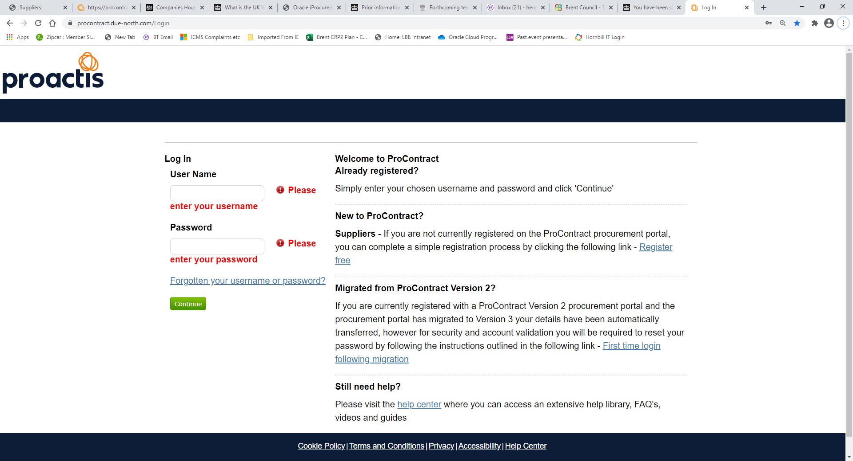

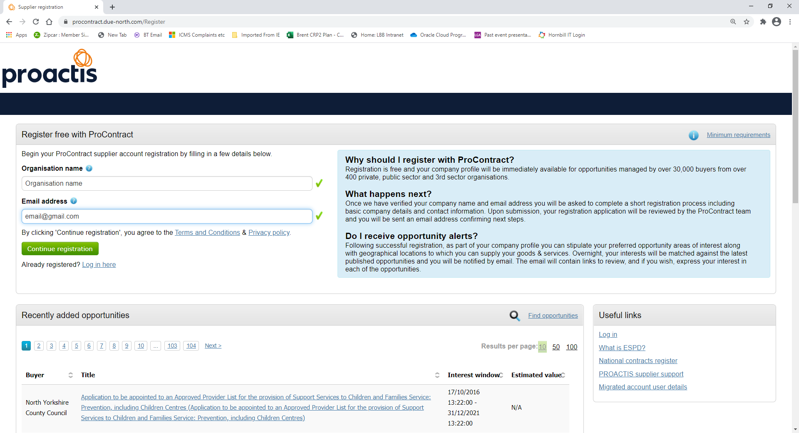

We suggest you use an email address such as ‘info@supplier1.com’, rather than one held by an individual – so that messages will continue to reach your firm even if a colleague is away or ceases to work for the firm.

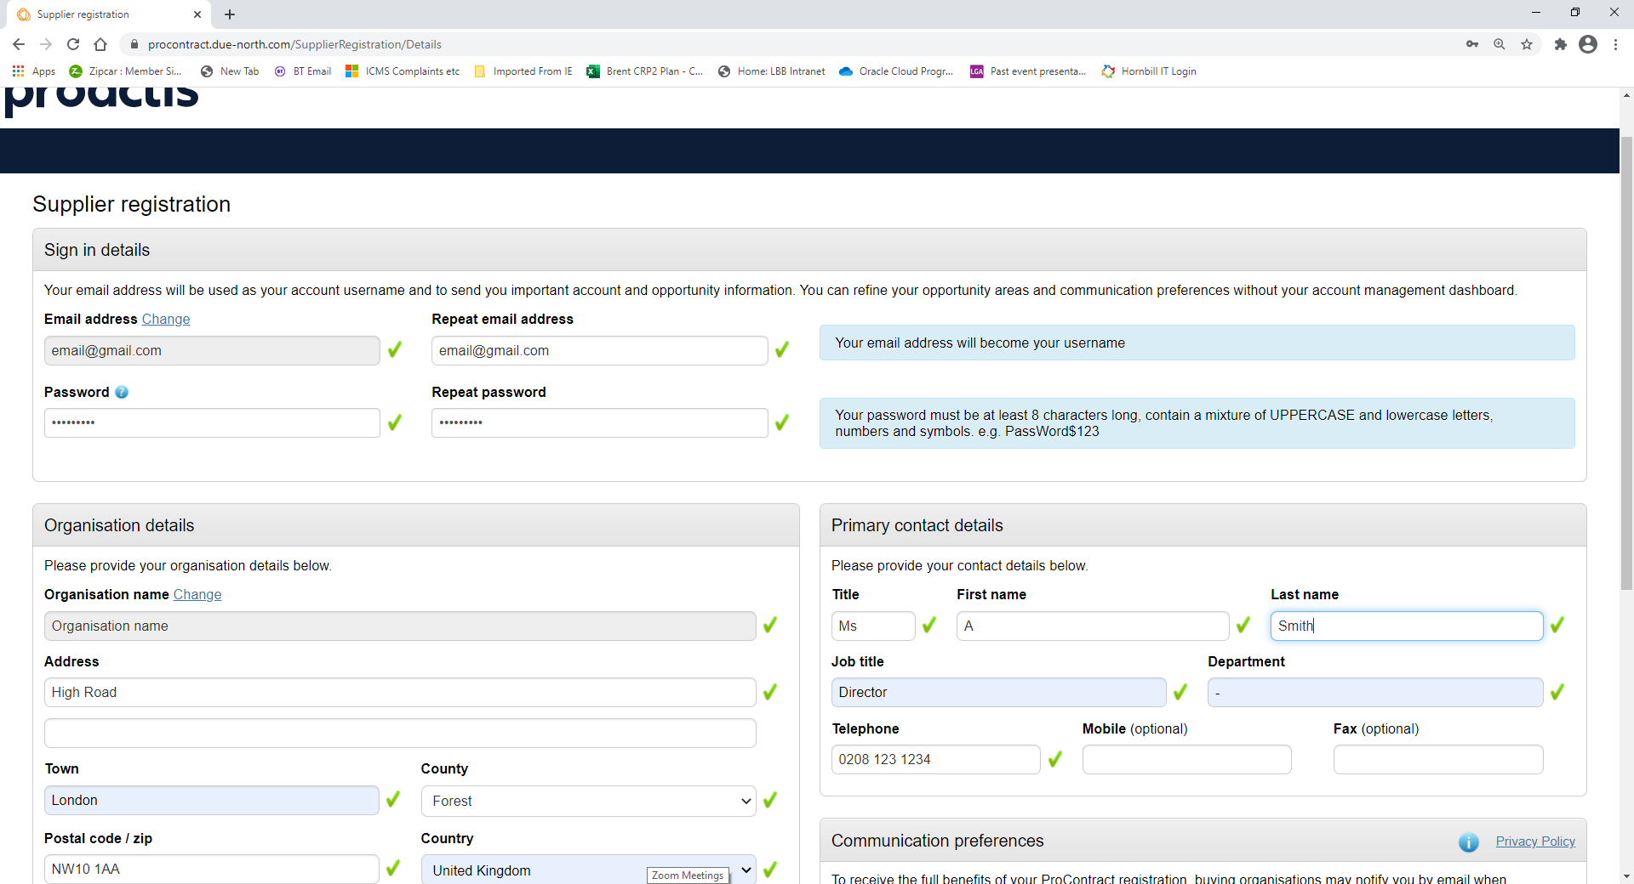

Complete the form – your email will be your login.

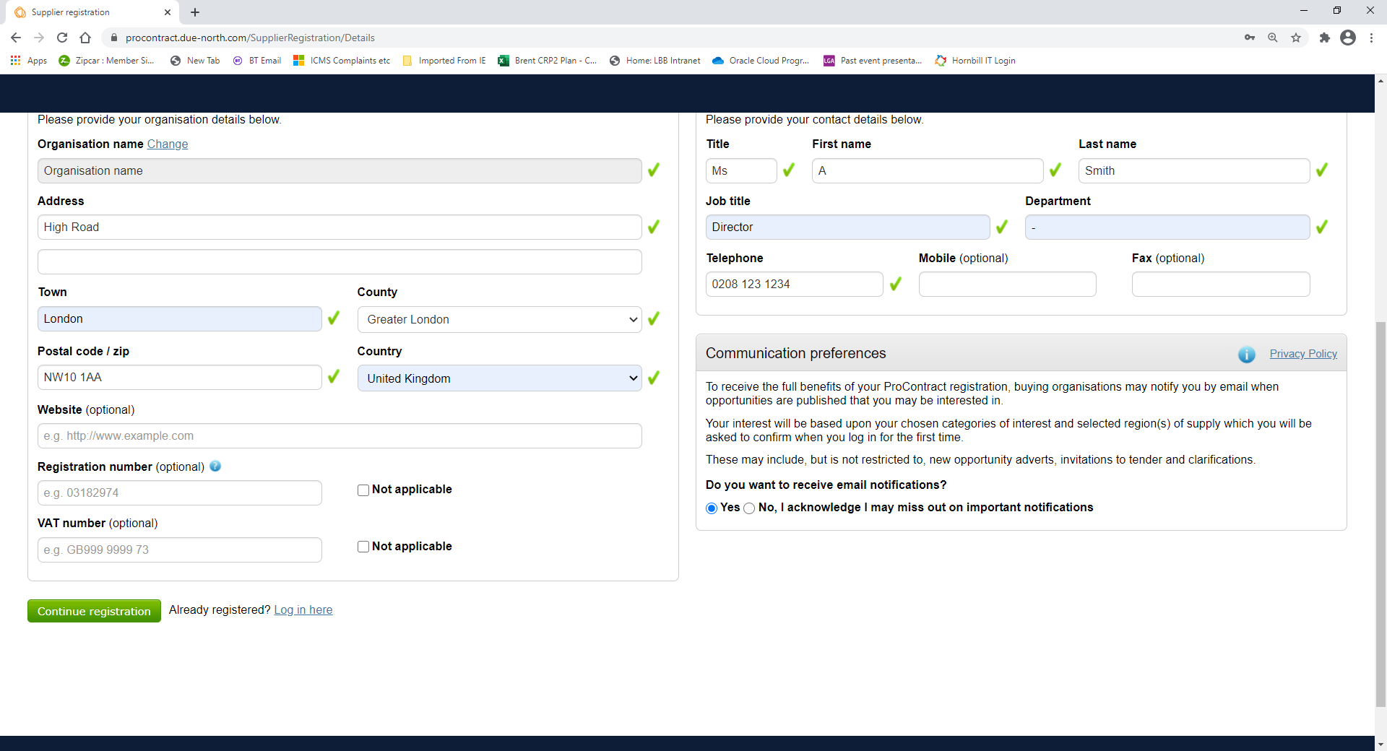

If information is missing (*e.g.*, VAT number might be Not applicable), error messages will appear and you will need to make corrections before proceeding. Please ensure you select Yes to receiving email notifications.

Once you have completed the form, click on Continue Registration.

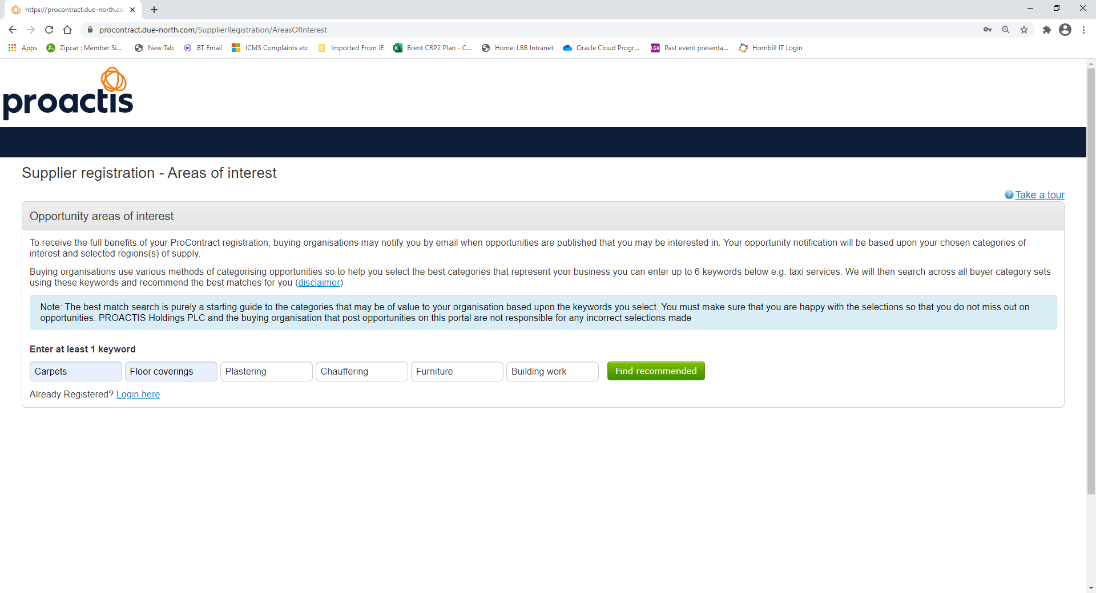

Enter the keywords that apply to up to six areas of business that you are interested in. Then click on Find recommended.

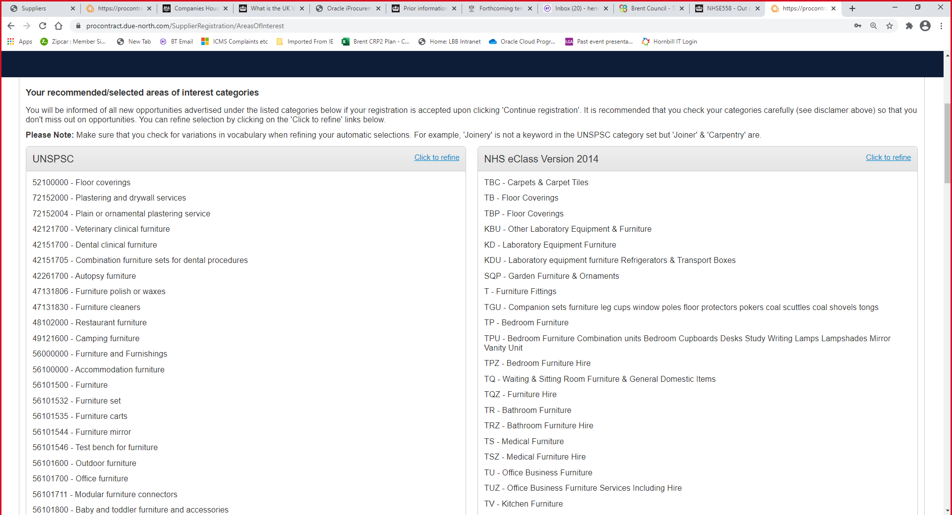

Proactis translates your (up to) six Areas of Interest into the category codes used by the UN (UNSPSC), the NHS (NHS eClass Version 2014), the EU (CPV or Common Procurement Vocabulary) and Proclass (widely used by local authorities). Use the Click to Refine link to adjust the categories that you want to be notified about.

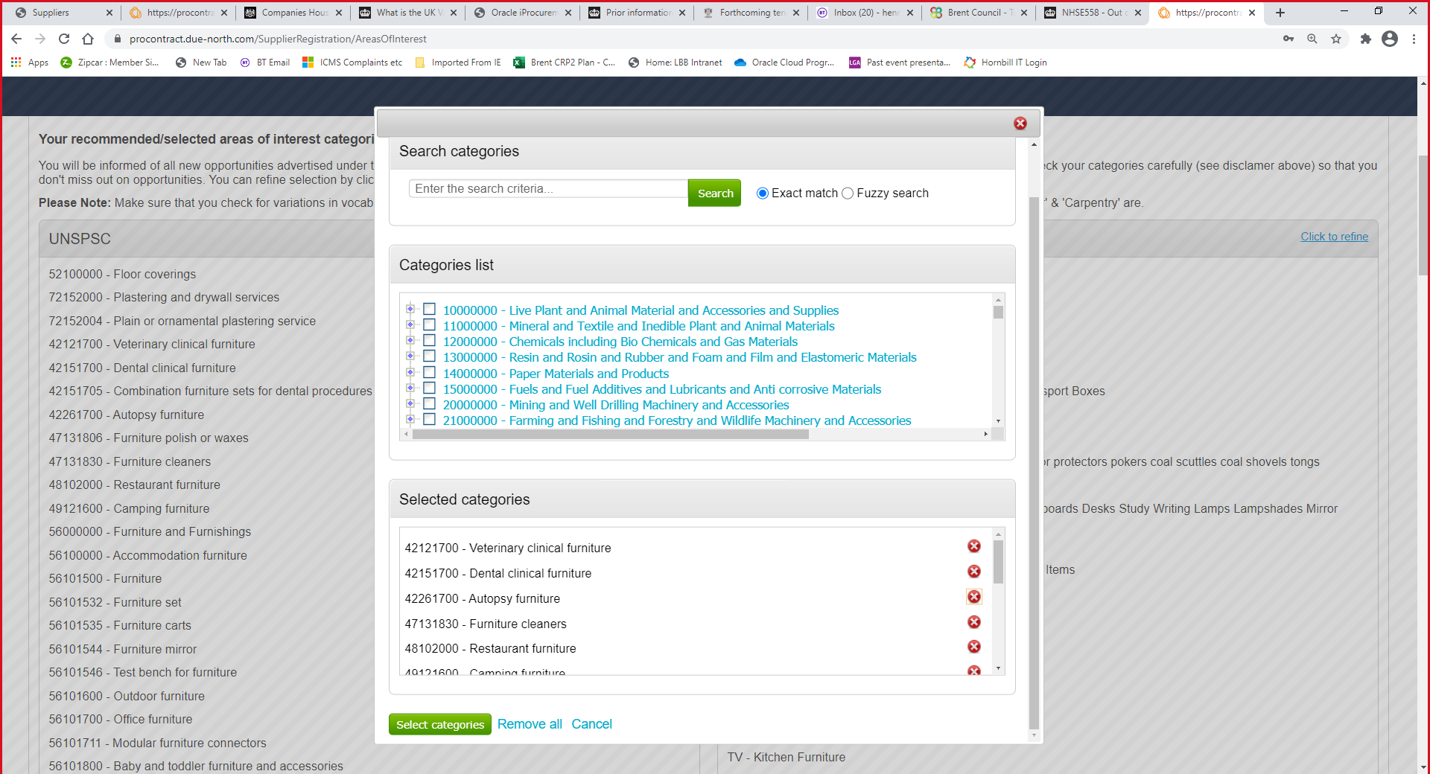

You can remove the categories in which you are not interested.

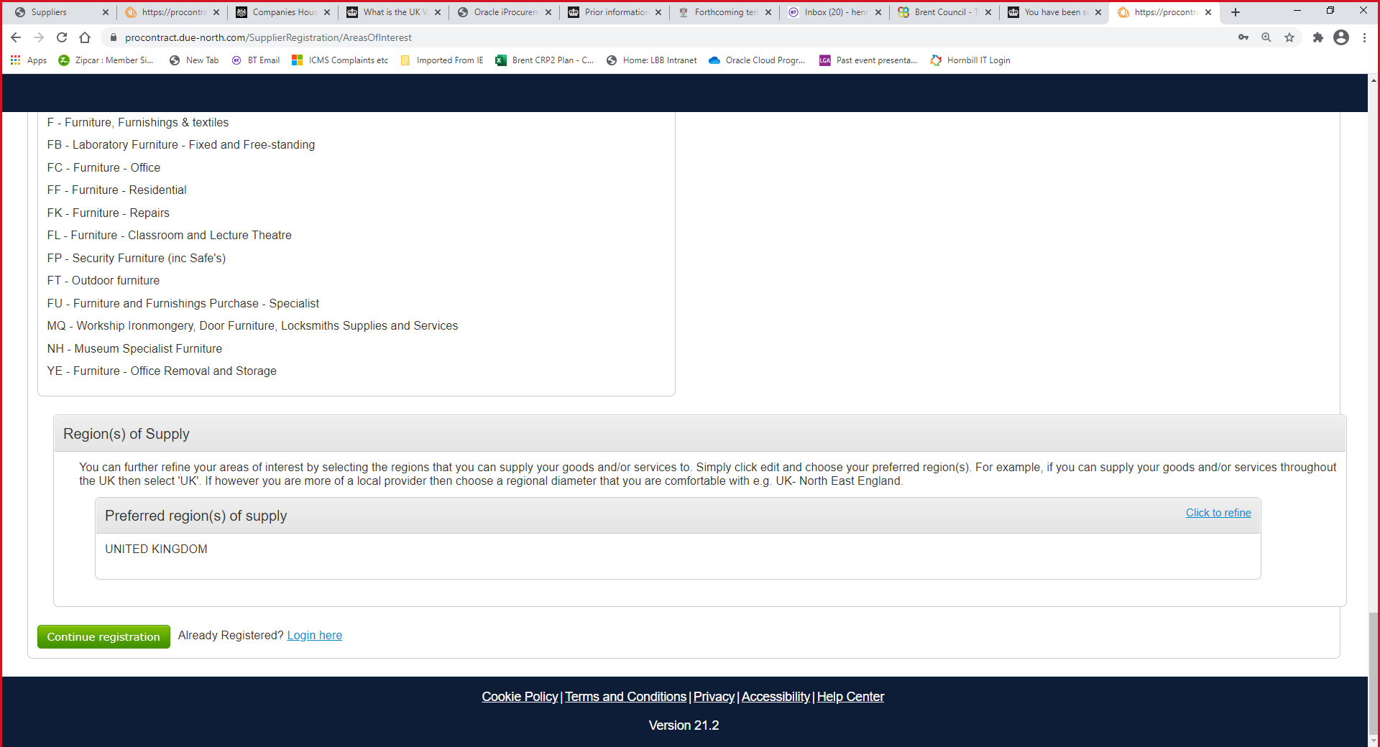

You can also select the geographical areas (of supply) about which you wish to receive notifications. Click on Continue Registration when you have completed your selections.

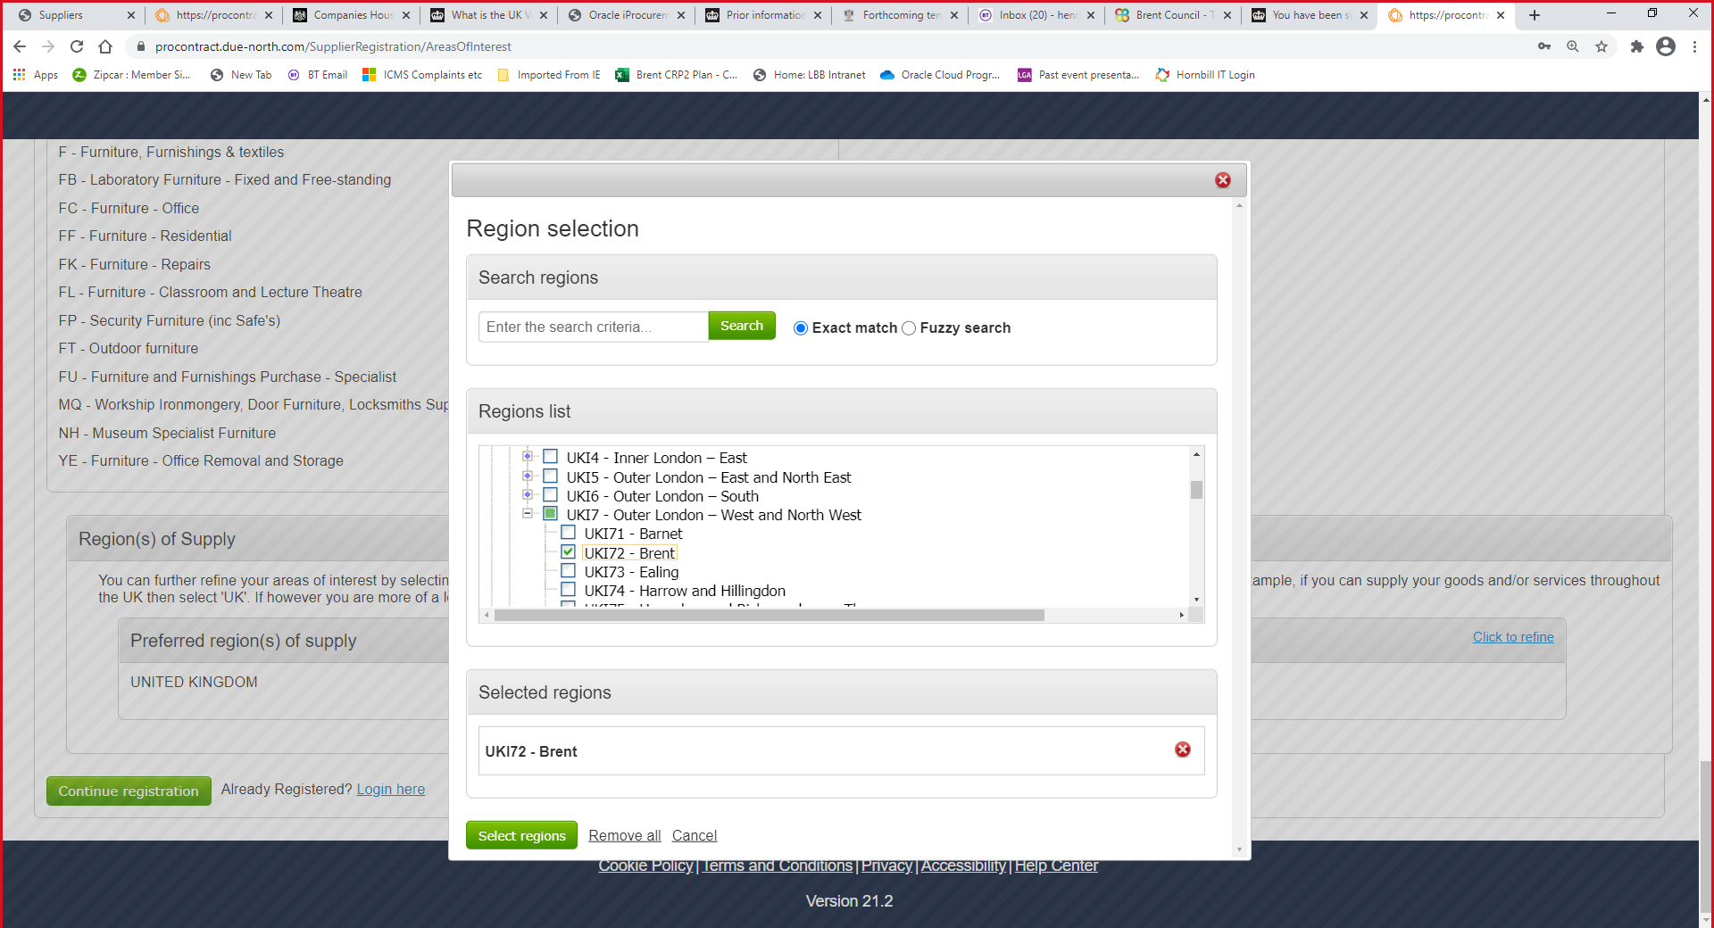

Follow the steps to select the region and then click on Continue Registration.

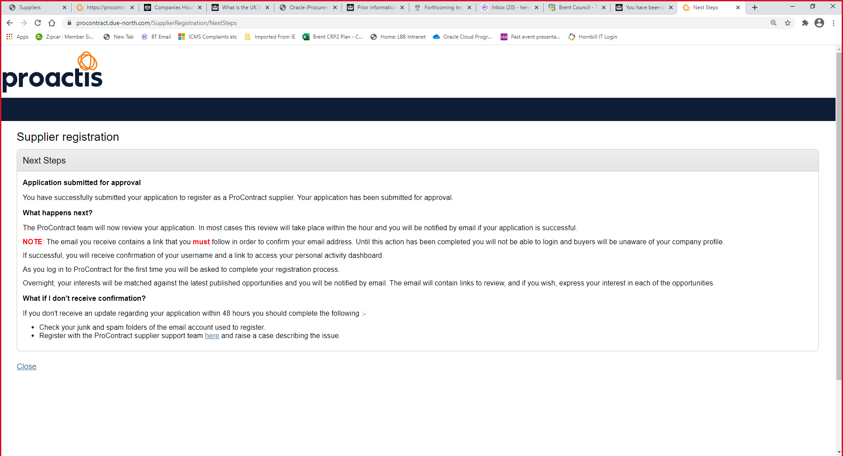

You should look out for the confirmation email that will contain a link for you to confirm your email and other details.

Once your account is set up, you can also change your selection of Categories at any time, following the link in Workgroups:

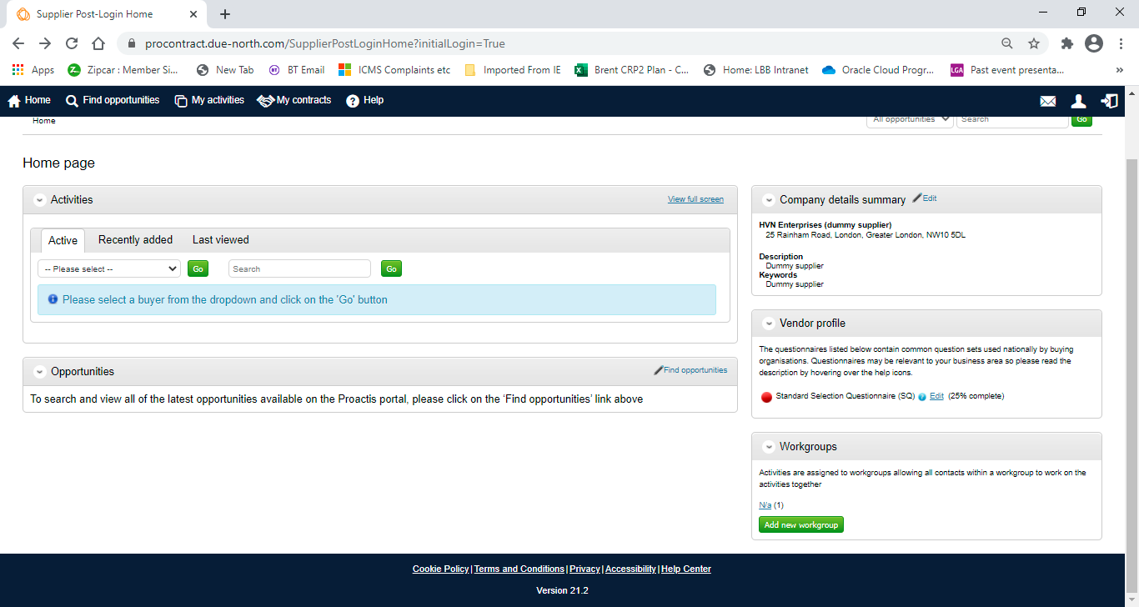

As well as the Categories that a supplier selects during registration or later, you can search for new tendering opportunities at any time using the Find opportunities function.

*Finis.*