**Action:** Find out when Barnet’s next consultation stage is for their draft Local Plan. The view from Golder’s Hill to Harrow on the Hill needs to be agreed with Barnet / get a statement from Barnet that this is the correct view Needs to be a map accompanied by a statement saying we have both agreed it.

**Summary of position:**

Two protected viewing corridors toward Harrow on the Hill pass through Brent from Barnet. These include views from Millfields Park, and Golders Hill Park. These views were identified in Barnets 1991 Unitary Development Plan. Although the views were protected, their protected corridors were ill defined. The inspector therefore requested the Council establish a common ground on the designation of these corridors with the London Borough of Barnet.

Barnet is currently drafing a new Local Plan. They have recently gone out for regulation 18 stage consultation. They aim to undertake their Regulation 19 stage consultation in the summer of 2021. Therefore, although they intend to take the protected views forward into their new Plan, they are yet to receive the full scrutiny of the Local Plan consultation process. The LB Barnet has therefore provided the below statement with regards to these views:

*‘Barnet Council is progressing its Reg 19 Local Plan and as part of this work it is reviewing the Locally Important Views and the impact they have on our neighbouring boroughs. As part of our Duty to Cooperate responsibilities we will discuss the 2 views from Golders Hill Park and Mill Field toward Harrow on the Hill with both LB Brent and LB Harrow. This is also clarified by the attached map.’*

The attached map referred to is included in Appendix A. The original viewing corridors, with which the inspector took issue, are included in Appendix B. The Council was originally concerned with the direction of the cone, in that they did not appear to focus upon St. Mary’s Church atop Harrow on the Hill, and the breadth of the views, given their distant and relatively small focal point. Appendix A demonstrates how these concerns have been taken into consideration, with both cones arriving at the same destination. They are also much more narrow in their breadth, appearing to only include their focal point upon arrival. The Council is therefore satisfied with these new cones, and the areas of land which they pass through within the borough. However, as stated within LB Barnets statement, we will continue to work with them throughout the drafting of their new Local Plan in the firming up of these views in response to representations received, as part of our Duty to Cooperate.

Appendix A – Updated views which constitute part of Barnets new draft Local Plan as a result of discussions with Lb Brent.

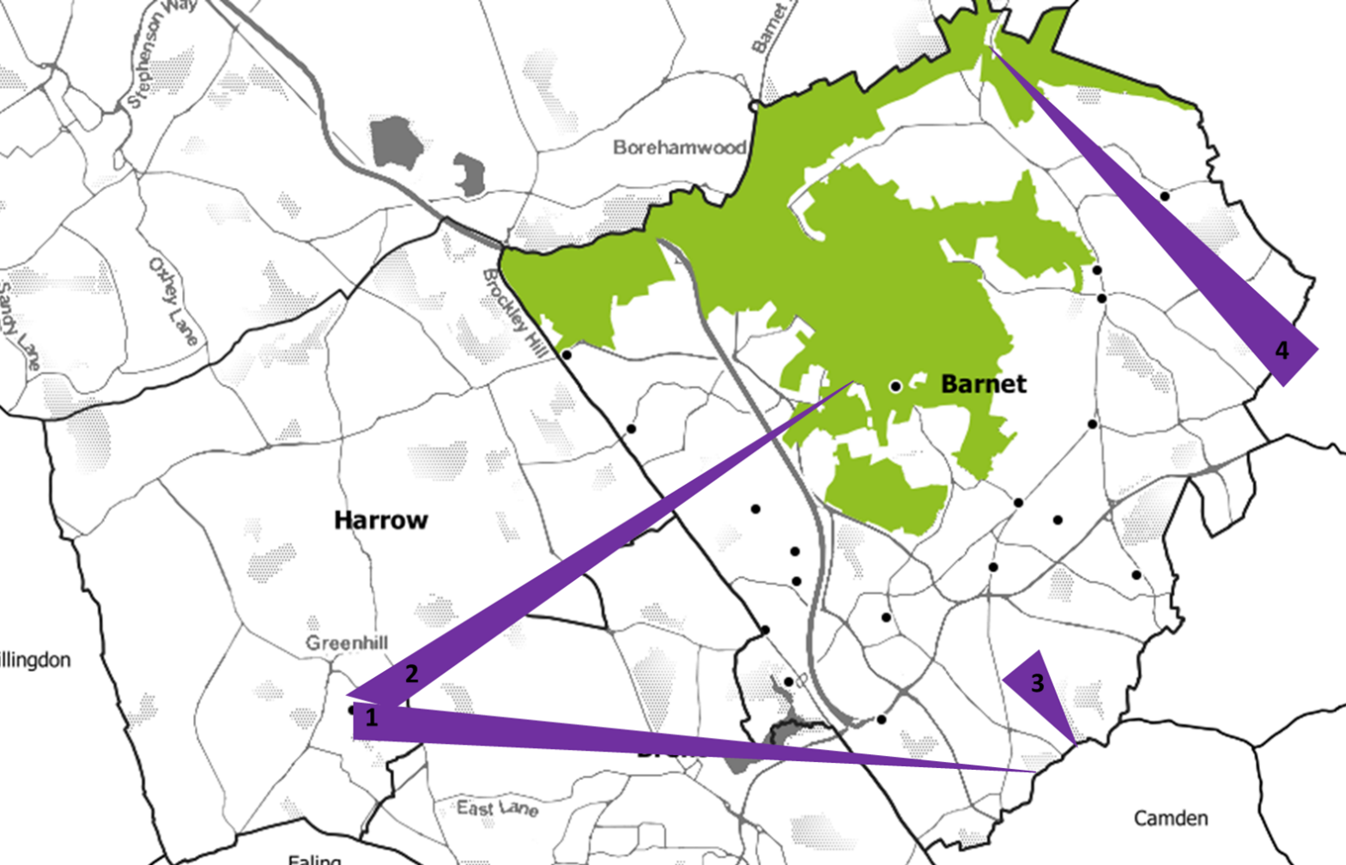

1 = Golders Hill Park toward Harrow on the Hill

2= Mill Field Park toward Harrow on the Hill

Appendix B – Barnet proteted viewing corridors prior to engagement with LB Brent.

