# Changing

times

Helpful points to remember

## Predictable Routine

Children feel secure when they know what is happening and when.

## Music & Dance

Music helps regulate emotions and can create relaxation and happiness. Dancing promotes self expression and enhances physical well being.

## Physical/ Outdoor Play

Outdoor play is essential to children’s physical and mental wellbeing. Children learn about the world around them and themselves. Physical skills promote self- esteem, resilience and social skills.

## Sensory Play

Sensory play has many benefits, including forming brain connections and supports language development and calming for body and mind.

## Stories & Rhymes

Singing together promotes bonding and releases positive hormones such as endorphins. Stories create time for connection, encourages talk though books, mark making, pretend play and small world play.

## Talk & Play

Believe that every second with children is important.

Be aware of everyday opportunities to talk and connect through play.

## Time in Nature

Being in nature reduces anxiety and stress and significantly increases wellbeing.

## Role Play

Role/Pretend play helps children to work through and manage emotions.

This can be supported by adults who sensitively follow the child.

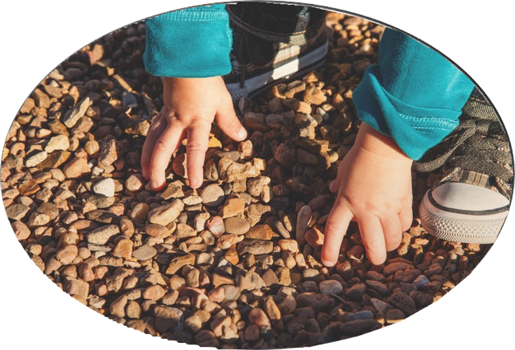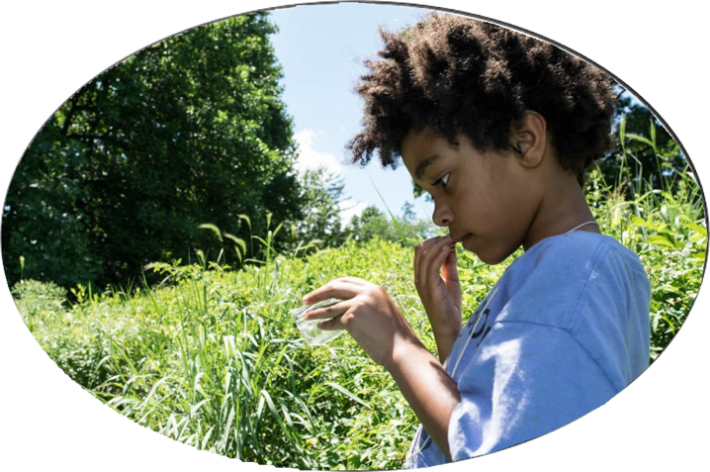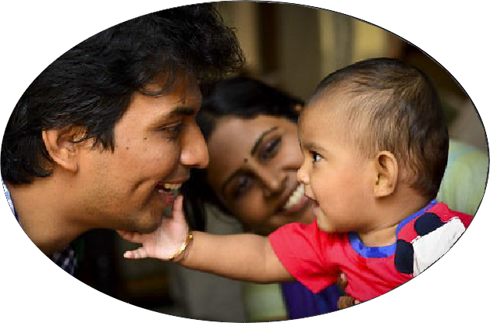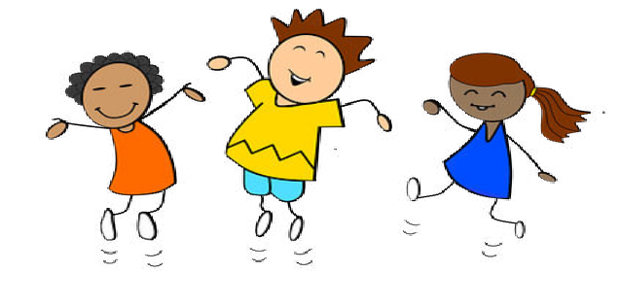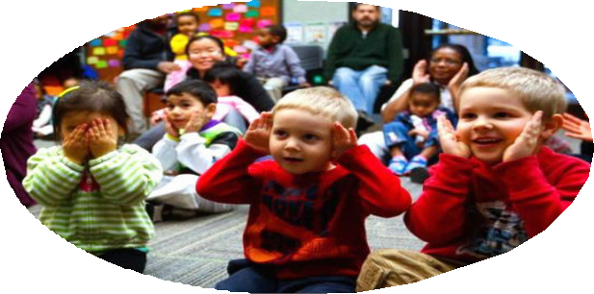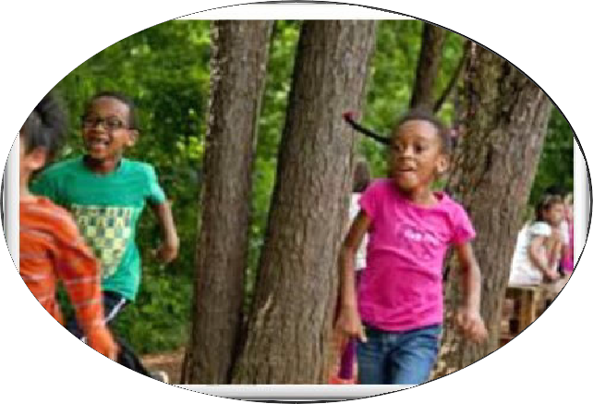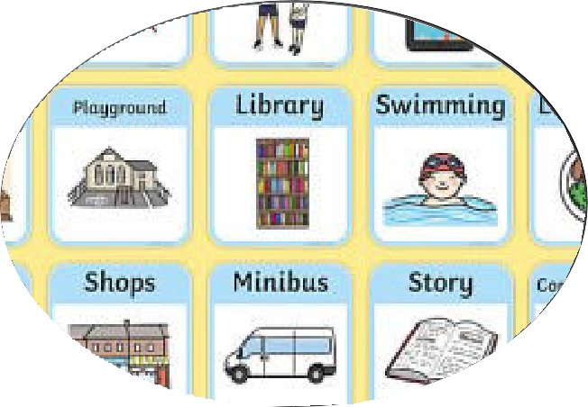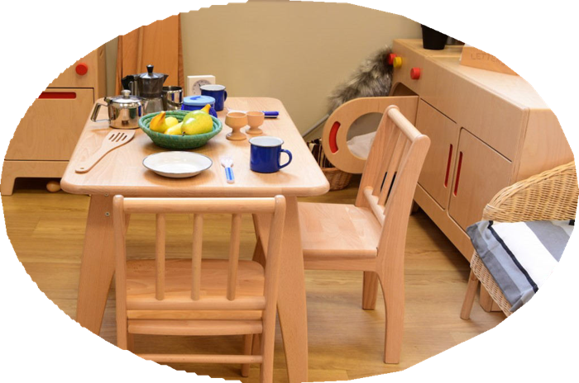

[**www.brent.gov.uk/earlyyearsinclusion**](http://www.brent.gov.uk/earlyyearsinclusion)