**Nucleus 7 maintenance**

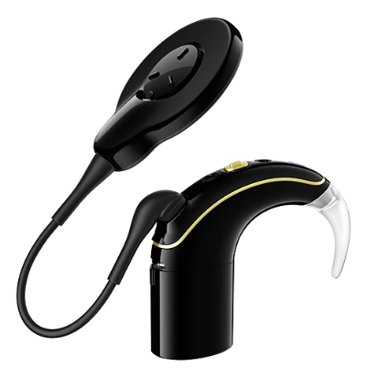

**Batteries: disposable and rechargeable**

* small rechargeable should last up to 19 hours
* bigger rechargeable should last up to 40 hours
* disposable batteries should last up to 48 hours
* batteries should be changed/charged every day

**Top tips:**

1. Before bed-time wipe the outside of the processor, coil and cable with a soft dry cloth; this prevents dirt building up.
2. Place it in the *dry&store* container overnight which removes moisture from the inside. Do this every night to prolong the life of your processor. In your *dry&store* container you have a dry-brick to absorb all the moisture; this needs to be changed every 2 months.
3. Once a week take apart your processor leaving the ear hook attached, clean it with a soft dry cloth. Then gently tap or blow on the battery contact to remove dust.
4. The microphone on your processor has a protective cover to keep dust and moisture out, they can get clogged over time and must be changed every 2-3 months.
5. Make sure your cable is the right length if not they can get twisted and break.
6. Please avoid getting sand or dust in your processor.

<https://www.youtube.com/watch?v=hi4pQosWtfQ&feature=share>

<https://www.youtube.com/watch?v=K16My_yluRo&feature=share>

<https://www.youtube.com/watch?v=K16My_yluRo&feature=share>

<https://www.youtube.com/watch?v=hi4pQosWtfQ&feature=share>