**Roger Touchscreen use and maintenance**

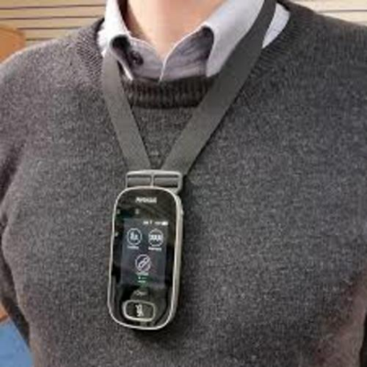 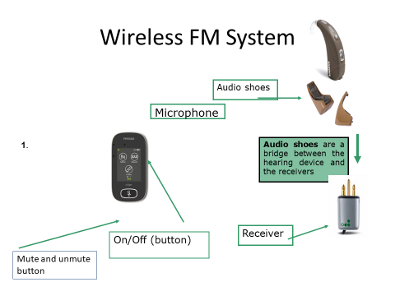

**Roger Touchscreen use**

Please watch the following video:

<https://youtu.be/dfe9TVjl180>

Please note:

* Put the microphone over your neck making sure the microphone is a pen’s length away from your mouth.
* Switch the touchscreen on by pressing on the button on top left hand side. It should then flash green, which means that the microphone is on.
* When you have attached the receivers to the hearing aids please press connect on the Roger touchscreen for each hearing aid. Repeat this every time the transmitter is switched off or the receivers are disconnected or removed from the hearing aids.
* To connect the Roger Pen to any tablet/phone/Ipad, please insert the USB audio cable into the headphone socket and connect it to the pen.

**Roger Touchscreen maintenance**

1. Keep all equipment in the case or box provided.
2. Make sure the transmitter is switched off before charging. (It is safe to leave it on charge overnight).
3. Make sure the battery drawers on the hearing aids are closed when the receivers are attached.
4. Check the batteries daily as the FM system uses the batteries more. If you are using your FM system daily please change the hearing aids batteries twice a week. (Please note that if the hearing aids batteries are low the transmitter will not connect and the batteries will need to be replaced).