**Looking after your hearing aids at home**

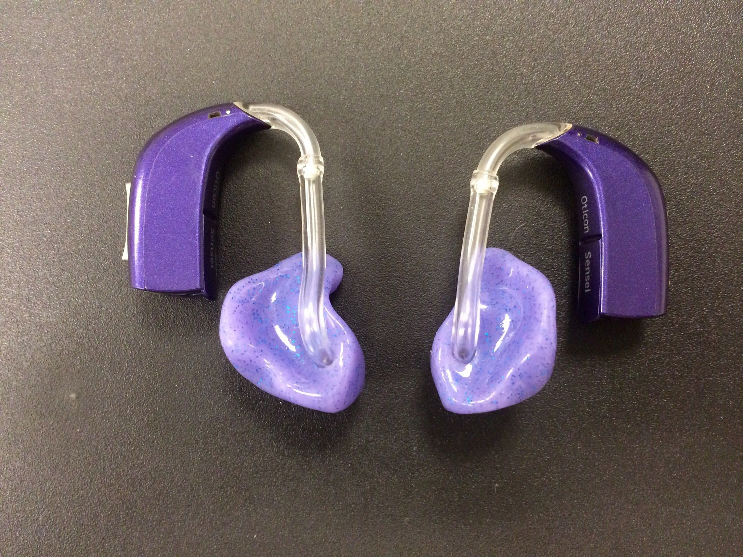

The better care you take of hearing aids, the longer they will remain in proper working order. Understanding how to clean and maintain hearing aids is very important in order to get the maximum benefit from them.

Please use the link below to watch how to carry out daily checks for hearing aids. There is also advice on trouble shooting and resolving minor problems.

<https://www.youtube.com/watch?v=nl3WRngfB5g&list=PL7B1043ABAEC9A100&index=2>

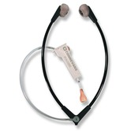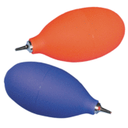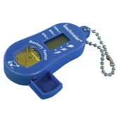

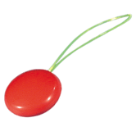 Stetoclip Puffer Battery Tester

Tubing threader

Please contact your Teacher of the Deaf if you require further explanation / advice or require any of the tools mentioned in the video to maintain good working hearing aids.