
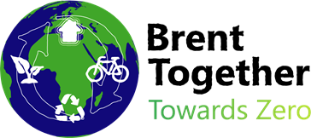

Survey Template for Schools – Nature, Waste and Consumption, and Energy

In the Brent Schools Climate Action Guide, Section 2 is all about helping schools to understand their context. As part of this, you may wish to understand some of the attitudes and behaviours children have towards climate change, environmental issues and climate action.
This survey template is designed for schools to use with their pupils to understand their thoughts, behaviours and attitudes on nature, waste and consumption, and energy. The survey can be adapted to suit your schools’ needs and context, and there is space to add your own questions.
The survey is short, so pupils can complete it in lessons, tutor time, or as a home activity. There is also some guidance at the end for eco-committees, or another group of pupils, to collect and analyse the results. The results are for the school to understand their context and shape their Climate Action Plan.
We recommend using this survey digitally where possible, to reduce the need for printing. If you do need to print these surveys, we suggest removing the photos and displaying these on a screen instead.
To measure other areas of your school, such as biodiversity, travel, or the energy-efficiency of the site, please check Page 13 of the Brent Schools Climate Action Guide.
Please turn to the next page for the survey.

Pupil Survey – Nature, Waste and Consumption, and Energy
Our school is taking steps to help protect our planet from the impacts of climate change. To help us with this, we would like to ask everyone what they think about climate change and what everyone is doing to protect the planet. You can help by answering these questions!
You can answer these questions as honestly as you like because your name will not be written down. Remember that there is no right or wrong answer to these questions!

What year group are you in? ___________________________________

Nature
Nature means all the things about our environment that are not created by humans. This could be a place where you can see trees, plants, animals, or the natural landscape. These photos show what nature looks like in Brent. These questions are about how you feel about nature.
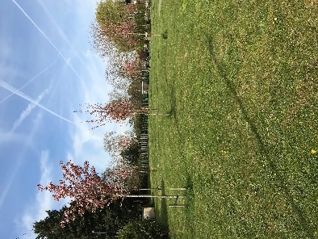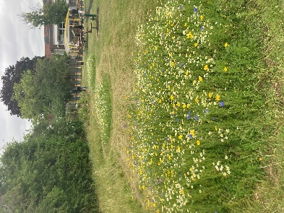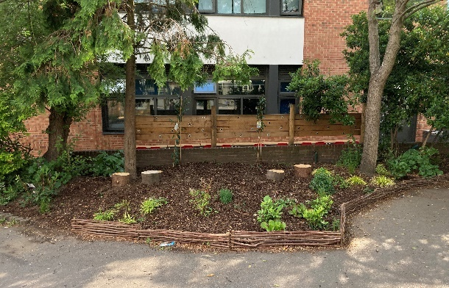
- How much time do you spend outdoors in nature?

Please tick one answer

- I spend time outdoors in nature more than 7 hours a week

- I spend time outdoors in nature 5-6 hours per week

- I spend time outdoors in nature 3-4 hours per week

- I spend time outdoors in nature 1-2 hours per week

- I spend time outdoors in nature less than 1 hour per week

- I’m not sure how much time I spend outdoors in nature

- How much do you enjoy being outdoors in nature?

Please tick one answer

- I love being outdoors in nature

- I like being outdoors in nature

- I don’t like being outdoors in nature

- I hate being outdoors in nature

- I’m not sure how I feel being outdoors in nature

- What do you enjoy about being outdoors in nature?

Please tick one answer

- Playing with friends

- Exploring plants and animals

- Enjoying the fresh air

- I don’t enjoy being outdoors in nature

- I’m not sure / something else

4. How do you feel about climate change and its impact on nature?

Please tick one answer

- I feel very worried

- I feel a little bit worried

- I am not worried at all

- I’m not sure

- I don’t know what climate change is or what its impacts are on nature

Space for schools to add their own question:
5.

Waste and Consumption
When we throw our rubbish away, it is sometimes buried in the ground (landfill) or burned, which is bad for our planet. To stop this, we can re-use things, recycle, or reduce how much we buy in the first place. These questions are about what you do to help reduce how much rubbish (waste) there is in our planet.
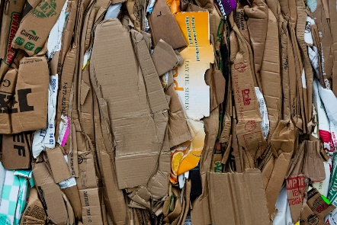
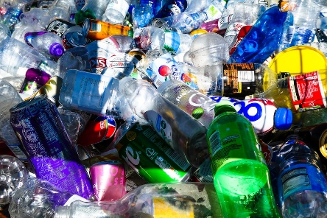
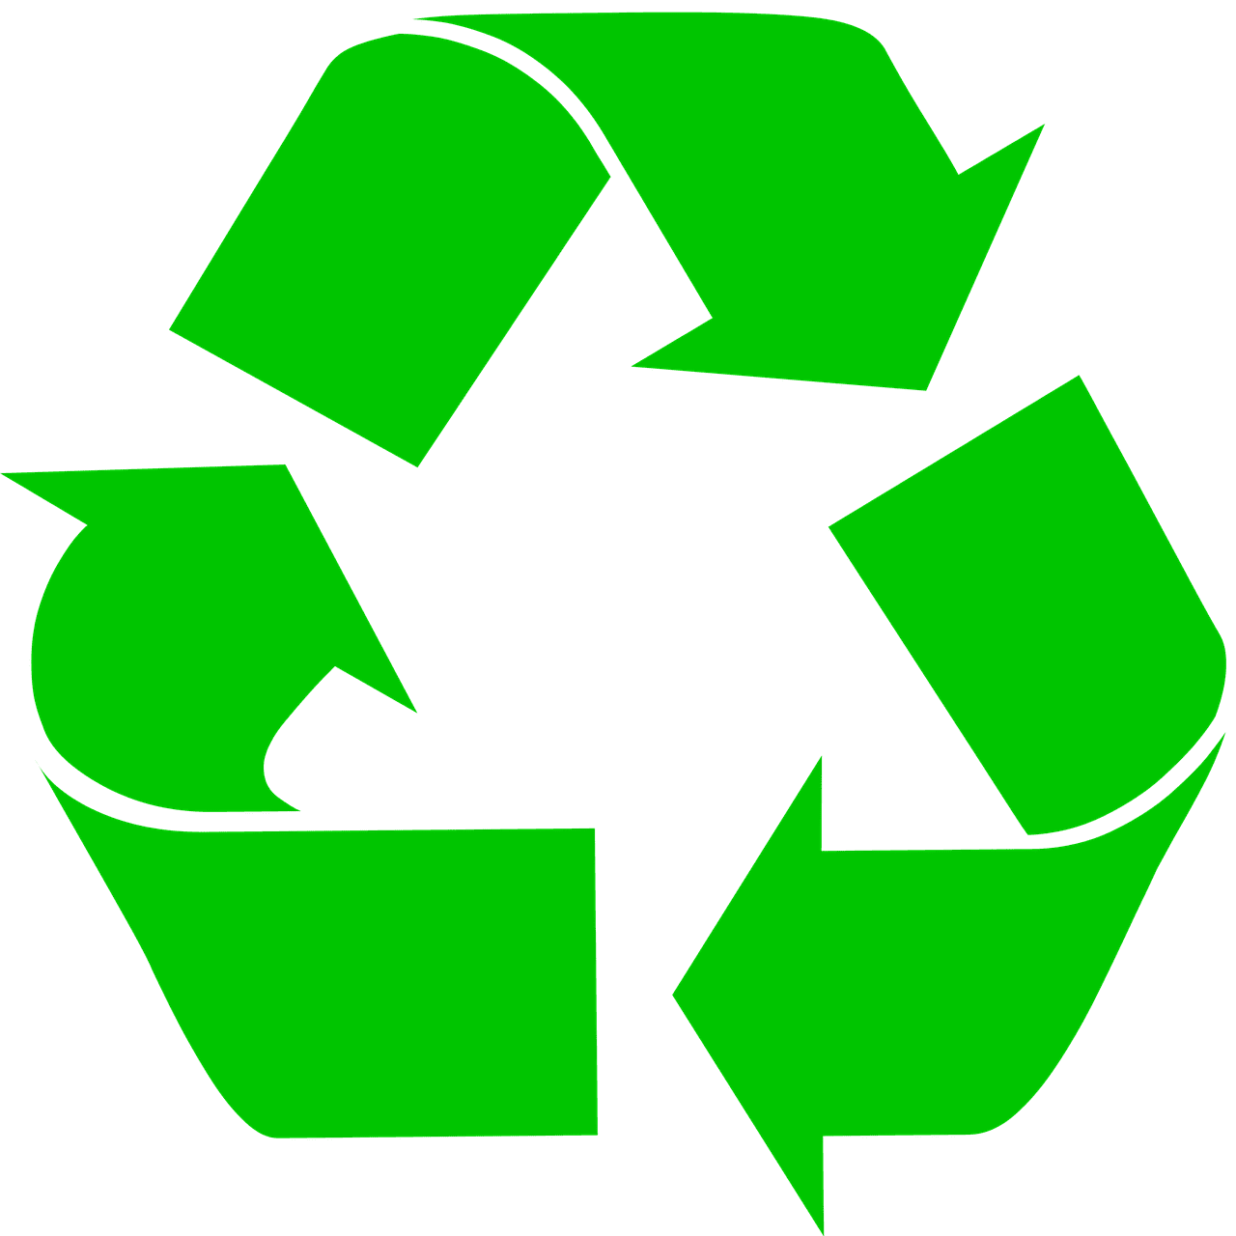

- When you throw away rubbish that is made of paper, cardboard, plastic, glass or tin, how often do you put it in the recycling bin?

Please tick one answer

- Every time

- Sometimes

- I forget to recycle most of the time

- Never

- I’m not sure

- There are lots of things we can do to reduce how much rubbish there is in our planet. The list below shows some examples.

Please put a tick next to all of things that you do to reduce waste.

- I re-use plastic bottles before I throw them away

- I have a bottle or a cup that I can re-use for a long time

- I/my family/my school have a compost bin at home which we put food waste in
- I/my family use re-usable shopping bags that last a long time

- I/my family/my school grow our own fruit and vegetables

- I, or someone at home, repair my belongings when they are broken or damaged. This means I don’t have to throw them away and buy new ones

What else do you do to reduce waste? Please write down what you do here:

- Sometimes it can be difficult to reduce how much waste we throw away. The list below shows some reasons why this can be difficult.

Please put a tick next to all of the reasons that make it difficult for you to reduce waste

- There are no recycling bins for me to use

- I don’t know why we need to recycle

- I do not have a compost bin at home

- I don’t know how to grow my own fruit and vegetables

- I do not have anywhere to grow my own vegetables

- I, or someone at home, don’t know how to repair my belongings when they are broken or damaged. This means we have to throw them away and buy new ones

What other reasons are there that make it difficult for you to reduce waste? Please write them down here:

Space for schools to add their own question:
4.

Energy
Energy is used to power things like lightbulbs, TVs, computers, washing machines and lots of other things! Sometimes, energy comes from burning coal, oil or gas (fossil fuels) which is bad for our planet. We need to use less energy to help our planet! The questions below are about how you help to save energy.

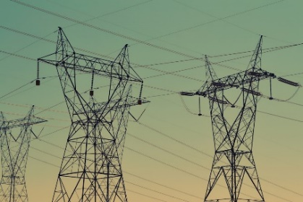
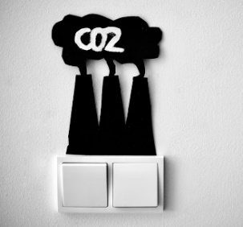

- What do you do to try and save energy?

Please tick all the things that you do

- I turn off lights, TVs, computers and other things when I am not using them

- I try to remind other people to save energy as much as I can

- I try to have a small amount of screen time so I can do things like play outside, practice my hobbies, or read.

- I find it difficult to save energy / I don’t know how to save energy

What else do you do to save energy? Please write down what you do here:

- How often do you try to save energy at home or school?

- I always try to save energy

- I sometimes try when I remember

- I don’t really think about it

- I find it difficult

Space for schools to add their own question:

Thank you for answering these questions! This will help our school with taking climate action

Analysing your results
With the help of your eco-committee, use the table below to collect and analyse your results! Consider adapting this for students to practice their maths skills. An example is provided below:
Example: Nature
 | Q1
Create a tally of how many people ticked each answer | A: I  B: II  C: II  D: III  E: II  F: II
Analyse your results using the sentence starters | - The most popular answer was D, 1-2 hours per week  - The least popular answer was A, more than 7 hours per week  - This means that most pupils in our school spend 1-2 hours per week outdoors in nature  - Our goal could be to increase how much time our pupils spend outdoors in nature

Nature
 | Q1 | Q2 | Q3 | Q4
Create a tally of how many people ticked each answer | A:  B:  C:  D:  E:  F: | A:  B:  C:  D:  E: | A:  B:  C:  D:  E: | A:  B:  C:  D:  E:
Analyse your results using the sentence starters | The most popular answer was…  The least popular answer was…  This means that…  Our goal could be… | The most popular answer was…  The least popular answer was…  This means that…  Our goal could be… | The most popular answer was…  The least popular answer was…  This means that…  Our goal could be… | The most popular answer was…  The least popular answer was…  This means that…  Our goal could be…

Waste and consumption
 | Q1 | Q2 | Q3
Create a tally of how many people ticked each answer | A:  B:  C:  D:  E: | A:  B:  C:  D:  E:  F: | A:  B:  C:  D:  E:  F:
Analyse your results using the sentence starters | The most popular answer was…  The least popular answer was…  This means that…  Our goal could be… | The most popular answer was…  The least popular answer was…  This means that…  Our goal could be… | The most popular answer was…  The least popular answer was…  This means that…  Our goal could be…

Energy
 | Q1 | Q2
Create a tally of how many people ticked each answer | A:  B:  C:  D: | A:  B:  C:  D:
Analyse your results using the sentence starters | The most popular answer was…  The least popular answer was…  This means that…  Our goal could be… | The most popular answer was…  The least popular answer was…  This means that…  Our goal could be…

