Inclusion Service Directory





**EARLY YEARS INCLUSION SUPPORT TEAM**

**Who are we?**

The Early Years Inclusion Support Team is made up of professionals from specialist Early Years backgrounds, including early years specialist teachers, Speech and Language Therapists and specialist practitioners.  The team is committed to promoting high quality inclusive early years education for children with a Special Educational Need and/or Disability.

**What do we do?**

* Our team works with young children at the Early Years Foundation Stage in Brent’s private, voluntary and pre-school settings, with childminders and in nursery classes in schools.
* With prior consent from parents/carers we will visit early years settings and advise staff on the identification, strengths and needs assessment and support of young children who may have developmental differences affecting their participation, learning and progress.

**What do we offer?**

* Working in partnership with parents/carers and all professionals involved to support the child’s needs within their setting
* Support for settings in meeting the national and local requirements for working with young children with SEND
* Observation of a child in their setting and related advice
* Support for practitioners around preparing documentation in co-production to support the inclusion of children with special educational needs
* Advice on assessment and referral routes
* Developing staff members’ understanding of special educational needs
* Guidance on transition to the next stage in a child’s education

**How do we work with early years professionals?**

* We offer a varied programme of training for Early Years professionals relating to SEND
* We provide a coaching and modelling style of partnership working onsite in settings with SENCOs and setting staff
* By chairing Under 5’s Nursery Panel and Statutory Notification Panel the Team Leader is able to work with multi agency professionals to support children to have their needs identified to Brent Council and access their educational entitlement in as timely a way as possible and in the best provision for them

**What do we not do?**

* Work with Reception + aged Pupils
* Facilitate moves back into nursery after a child has transitioned to school
* Make unilateral decisions around funding eligibility- this is via SENIF multiagency panels only
* Support admissions for unplaced school aged pupils
* Make recommendations regarding any Brent school or nursery to parents/carers
* Write supporting letters to housing to Brent or any other LA at parent/carer request
* Complete requests for Education, Health or Care Needs Assessments- these are triggered by setting or parent/carer

**How to Make a Referral:**

Referrals are made directly by the EY setting to their allocated EYIST worker. School SENCOs wishing to refer a nursery child can contact the team lead [Hatty.Besley@brent.gov.uk](mailto:Hatty.Besley@brent.gov.uk) for a case discussion and to request the referral form if required.

**PORTAGE SERVICE**

**Who are we?**

There are two Portage Officers within the Brent Portage Team. They have extensive knowledge of child development, as well as many years of experience working with children under five who have special needs.

**What do we do?**

Brent Portage is a home-visiting educational service for pre-school children with Special Educational Needs and Disabilities (SEND) and their families. It is for a child with a disability, additional needs or ‘developmental delay’. That means when a child is not progressing as expected in his or her understanding, thinking or physical development. The Portage model of service delivery is based on the National Portage Association (NPA) core aims and principles, these include:

* Helping children with additional needs and their families to learn together, play together, participate and be included in their local community
* To play a part in minimising the barriers often faced by young children with additional needs and their families
* Support the development of inclusive services for children

**What do we offer?**

Families receive weekly/fortnightly visits from their allocated Portage Officer.

The Portage Officer will arrive with a range of resources which they have carefully matched to the child’s developmental stage and interests. The activities will promote development through play.

There are three main elements to every home visit:

* Structured Teaching: where the focus is on providing activities which develop specific skills using the Portage Small Steps approach to learning
* Child-led play: where the aim is to observe self-initiated play to identify child’s current skill levels and interests
* Family Focus: an opportunity for parent/carers to share concerns and celebrate successes

**Who is eligible for Portage?**

Brent Portage will consider children up to the age of 4 years who have additional needs and not attending an educational setting/childminder. We would also look for two or more developmental delays. The Portage Service will review each referral on a case-by-case basis.

**What else do we offer Portage families?**

When a Portage Officer is assigned, they act as your Keyworker and are able to link you up with other services. Portage service also offers the below for all Portage Families:

* Fortnightly stay and play sessions
* Referral to other services
* Regular assessments of your child’s development
* Nursery transition support
* Support in applying for eligible funding and referral to various charities such as Little Village / New Life
* Keyworker role for an Educational, Health and Care Plan assessment request

**How do we work with other professionals?**

Within the Portage model, parents/carers are acknowledged as the people who know their child best and Portage Officers seek to build on this knowledge. The Portage Service works closely with other professionals such as Speech and Language, Physiotherapy, Occupational Therapy, Community Nursing, Child Paediatricians, BVIS, BHIS, Health Visiting, Boat, school / nursery SENDCo’s, EYIST and other health and multi-agency professionals. Joint visits may be arranged with other professionals if needed.



**THE INCLUSION SUPPORT TEAM**

**Who are we?**

The Inclusion Support Team is a service providing support for children and young people from 4 – 17 at risk of exclusion. The team provides a range of core services for Brent schools, supporting them and families to help reduce exclusions in schools.

**What do we do?**

The Inclusion Support Team supports Brent schools to bring about positive changes in the behaviour of children and young people. The teams aim is to improve behaviours for learning and reduce the risk of exclusion from school. The team draws on a range of multidisciplinary services within Brent to improve behaviour, identify the best packages of support for young people and support schools with their approach to inclusion. The team will also support schools and families at key transitional times of the school year, reintegration, facilitating and supporting managed moves and respite placements.

**What can we help with?**

* Consultations with schools about pupils
* Behaviour support in class and school
* Mentoring in school
* Pastoral Support Plans (Including the pupil, family and school)
* Observations and recommendations for school staff
* Managed Moves (advice and support transitioning)
* Advice on the implementation on reduced timetables
* Discussions about a Permanent Exclusion
* Parental support
* Guidance on Alternative Provision (including Brent River College and Ashley College)
* Whole school training
* Governors training on Exclusions
* Transition between Brent schools

**What we cannot help with but can signpost you to the right service:**

* Specials school/ ARP placements for pupils with an EHCP
* Amendments to an EHCP
* Admissions
* Elective Home Education
* Ashley College- Health Needs Panel
* CAMHS referrals
* SALT/ OT/ Physio referrals
* WEST referrals

**How to make a referral:**

* Always speak to your schools allocated Inclusion Support Officer before making a referral. Please contact [Pupil.Referrals@brent.gov.uk](mailto:Pupil.Referrals@brent.gov.uk) for more information.

**SEND 0-25 TEAM**

**Who are we?**

We are a dedicated team of individuals from a range of backgrounds, many from schools who work with pupils who have received an EHC plan from when a Needs Assessment is sought to the point that the plan is issued and maintained.

**The Team**

The team is organised in the following way;

SEND Service Manager

EYFS and Primary SEND Manager

EYFS and Primary SEND Officers

Secondary and Post-16 Manager

Secondary and Post-16 Officers

Annual review SEND Officers

Resolution SEND Officer

Transport Officer

Finance Manager

Finance Officers

**We can help with**

**The Brent local offer**

Each Local Authority must have a Local Offer; you can find Brent’s Local Offer here <https://www.brent.gov.uk/localoffer>

A Local Offer is a single place to come to find information and advice for children and young people with special educational needs and disabilities (SEND) aged 0-25, and their families.

• The EHCP process and time frame (20 weeks)

• The EHC Needs Assessment is a 20 week process

Once Brent SEN Team receive a request for an EHC Needs Assessment.

By week 6: Brent’s SEND Advisory Panel decides whether the assessment should start or not based on information received.

By week 16: If the decision was to assess, the Local Authority must by this point decide whether or not to issue an EHC Plan. If an EHC Plan is agreed Parents/Carers and/or Young person will have 15 calendar days to consider and provide views on a draft EHC plan and let us know their educational setting preference to be named in the EHC Plan.

By week 20: If an EHC plan was agreed, the ‘Final EHC plan’ is issued after you have had a chance to comment on and agree it.

**Way forward meetings (‘wfm’)**

If Brent Local Authority does not agree to an EHC Needs Assessment or an EHC Plan then a Way Forward meeting can be arranged with the Parents/Carers and educational setting.

This meeting is the first informal stage in helping Parents/Carers to understand why their child/young person has not been offered an EHC assessment or EHC plan.

It will:

• give you a chance to ask questions

• explain our decision not to start an assessment or issue an EHC plan

• explain the support your child/young person will receive and how this will be monitored

Attending a WFM does not affect their rights to appeal any decision you do not agree with.

**‘Yes’ to assessment**

If the SEND Advisory Panel agrees to assess then the SEND Team will ask for advice from professionals to contribute to the EHC Needs Assessment.

Professionals have 6 weeks from the date of the request to complete their information.

Templates for the advice has been designed and agreed with the individual professional team.

**Appeal to tribunal**

Parents can formally appeal to the First Tier Tribunal if they disagree with a decision taken by the council. This is sometimes referred to as a SEND Tribunal.

The First-Tier Tribunal has powers including ordering local authorities to:

• carry out an EHC assessment

• make and maintain an EHC plan

• maintain a plan with amendments

Extended powers mean the tribunal can also make non-binding recommendations about the health and social care aspects of EHC plans.

If the Local Authority receives an appeal to Tribunal, the SEND Team will review the appeal and see if the additional information has changed their position if not then they will defend the case. The SEND Team representing the Brent Local Authority will call a professional meeting to discuss the appeal and decide on the next actions. At this point, they will call upon the most appropriate professional to support them with the appeal. Professionals may be required to do further assessments and consider the wording on the EHC Plan. Professionals will be also asked to attend the appeal as a witness and to answer questions about their report and the recommendations.

**The GAF-‘Graduated Approach’ as:**

“A model of action and intervention in early education settings, schools and colleges to help children and young people who have special educational needs. The approach recognises that there is a continuum of special educational needs and that, where necessary, increasing specialist expertise should be brought to bear on the difficulties that a child or young person may be experiencing.”

• Advice on Annual Reviews- when, who and how they should be held

• Support with the school meeting pupils' needs via an EHCP

• Forms for increased provision/funding requests under an EHCP

• Contact information for Brent School SENDCo

• Implementation of professional meetings around a YP with an EHCP

• Consultations for a school/college placement for a YP with an EHCP

**The SEN Code of Practice**

-Coordination with other teams where a placement is not working or the school requires support or advice

-Information and advice around the provisions within an EHC plan

-Help sign post towards other services such as;

-SEND Support are Speech and Language Therapy, Occupational Therapy, Physiotherapy, Children and Adolescent Mental Health Service. Welling and Emotional Support Team (WEST), Social Care, School Nurse, Specialist hospital departments such as audiology, Epilepsy, diabetic, SENDIASS

**We cannot help with pupils who do not have an active EHC Plan but can signpost you to the right service.**

Useful contacts:

[SEN.Casework@brent.gov.uk](mailto:SEN.Casework@brent.gov.uk) - general emails

[sen.assessments@brent.gov.uk](mailto:sen.assessments@brent.gov.uk) - request for EHC needs Assessment and

enquiries around the assessment

[sen.reviews@brent.gov.uk](mailto:sen.reviews@brent.gov.uk) - schools to send in Annual Reviews

[SEN.Transport@brent.gov.uk](mailto:SEN.Transport@brent.gov.uk) - enquires about SEND Transport

[SFinance@brent.gov.uk](mailto:SFinance@brent.gov.uk) - enquires about SEND Finance

[post16.sen@brent.gov.uk](mailto:post16.sen@brent.gov.uk) - enquiries for Post 16 pupils

**SEND SUPPORT TEAM**

The SEND Support Team is a small team that, as its core role, provides support for Schools in navigating robust, whole school, universal SEND provision. At present, we work across primary and secondary phases of education. The team provides a range of services for Brent schools, whether that be something as complex as a whole school SEND review, to ensuring that your staff feel empowered to provide outstanding inclusive practice. Our aim is to support Schools in maximizing equitable learning opportunities for young people who have a range of learning needs. We may do this in the following ways:

Whole School SEND Review

The Graduated Approach Framework

Whole staff training and development

SENCO Support, Forums and Inductions

School consultations

Advice and guidance on all matters SEND

**Who do we support?**

We support schools, from learning support assistants to Headteachers, and those who govern in embedding high quality, inclusive practice for children and young people with SEND. Our focus is practice, and the structures in place in your setting that support aspirational teaching and learning, irrespective of need.

**Core offer**

All support and intervention strategies are evidence based and researched programmes. This core offer is available to all schools and may include:

Pupil Support

School / Staff Support

Work with classes and small groups

Working collaboratively with Early Help, Social Care, YOS and a range of other services

Indirect assessment through classroom observation

Partnership working with schools, families and pupils

Classroom observations to support inclusive practice

INSET training around Brent’s GAF

Induction support for ECTs and new teaching staff

RHSE and Anti Bullying Support

Governor and Headteacher training around SEND

In-depth review of SEND policy, systems and routines

Advice to staff on appropriate intervention strategies

Developing inclusive practices and the support for all areas of SEND

Classroom observations and feedback

Signposting to services for further, more specialist support

**SEND Support Team Staff**

All Brent Schools have a designated Advisory teacher, who will be the key contact for a group of primary and secondary schools in representing the SEND Support Team and signposting schools onto other specialist services. At present, we work across three clusters – one of which is predominately secondary.

Our SEND Support Team Manager provides additional support to Schools that have an ARP or are considering developing one within their setting.

Below are some examples of what our team can provide:

Advisory consultations either in School, via Teams or over the phone

Advice and guidance to head teachers and other senior leaders around SEND based practice

Development of school policies including in-depth reviews

Advice and support to SENCOs with their role, including induction training and forums

Classroom observations to support inclusive practice

Support for school transition planning at key stages

Whole school INSET and CPD Support, as well as cluster support through network meetings

Training and development of the school’s pastoral team / Heads of Year in relation to inclusive strategies

Identifying and supporting good practice in relation to teaching and learning

Supporting a range of referrals to specialist services

Supporting with whole school inclusive RSHE curriculum

Supporting with training and development needs

**Referral**

Please email: [sendsupport@brent.gov.uk](mailto:sendsupport@brent.gov.uk)

**Online referral form:** <https://forms.office.com/e/RetUVfcnks>



**THE EXTENDED DUTIES TEAM**

**Who are we:**

We are a group made up of an advisory teacher and education support officers who work with children and their families, when the children are known to social care as they are on a child in need or child protection plan. We are also able to work with children and families that were previously known to Brent Social Care.

**What we do:**

* Provide consultation, advice and recommendations to teachers, support staff, social workers, parents, carers and other professionals on strategies, programmes and interventions to promote social inclusion and better outcomes for identified vulnerable children, who currently have a Brent Social Worker
* Advise social workers on the completion of the education element of plans (IEP’s, PSP’s, support plans, safety plans, etc.), EHCPs and actively drive-up standards
* We are proactive in preventing exclusions, raising attendance and attainment and removing barriers to the achievement of vulnerable children and young people, who have a social worker or have recently had a Brent Social worker
* Liaise directly with designated safeguarding leads and other senior leaders in schools to raise the achievement, attainment, attendance and access to services of identified children and young people who are known to social care

**How we work:**

* A referral is made by schools or social care requesting information, advice, guidance or direct work with a family. After meeting with the referrer, someone from the team will make a decision as to the appropriate support, who will do what, when and timescales are agreed
* If information, advice or guidance is agreed our role is principally signposting
* If direct work is agreed this can include: supporting families to complete forms; going into schools to do training; attending meetings with other professionals to coordinate support
* We provide representation on various panels to act as the education advisors (EVVP, Placement Panel; Contextual Safeguarding Group)

**What we can’t do:**

* Direct either the LA School Admissions services, school-based admissions teams or Fair Access Panel to admit a child to a particular school or provide transport for children
* Direct SEND’s to issue an EHCP or speed up the process
* Direct schools not to exclude children
* Provide funding for equipment, services or support for children
* Diagnose children or young people who might appear to have SEMH issues
* Provide mentoring services
* Work with children who are currently Looked After or who are known to social care in another Local Authority

Contact: [paul.james@brent.gov.uk](mailto:paul.james@brent.gov.uk)

**BRENT DEAF AND HEARING SUPPORT SERVICE**

**Who are we?**

Our service aims to ensure all our children and young people have equality of opportunity alongside their hearing peers to reach their full potential.

Our team is made of four Advisory Teachers of the Deaf (Milly Mastroianni/ Sarah Hopwood/ Joanna Shareef and Karishma Parekh. A Deaf Instructor (Manjula Shah) and an Audiology technician (Marcia Davis).

**What do we do?**

* With prior consent from parents/carers BDHSS supports children and young people (CYP) from birth up to the age of 25 with an identified diagnosis of a hearing loss or APD (Auditory Processing Disorder) living and/or attending an educational setting in the London Borough of Brent

**What do we offer?**

* Deaf awareness trainings
* Advice on how to optimise the learning environment e.g. improving acoustics
* Advice on inclusive approaches and strategies
* Advice and support on effective use, care and maintenance of hearing equipment e.g. (hearing aids and CI)
* Regular hearing aid/CI (Cochlear Implant) checks;
* Support to parents/carers in encouraging hearing aid/ CI use
* Advice to enhance parents/carers’ communication with their child
* Auditory Verbal Therapy
* A Personal Assistive Listening Device
* Visits from a Teacher of the Deaf, Deaf Instructor and Audiology Technician
* Opportunities to learn British Sign Language (BSL
* Functional hearing and language assessments
* Contribution towards EHC assessments, Annual Review and Personal Education Plan (PEP) meetings
* Encouraging CYP to explore their Deaf Identity with the aim of enhancing their understanding and acceptance of their hearing loss and self -advocacy

Contact: [bdhss@Brent.gov.uk](mailto:bdhss@Brent.gov.uk)

**THE SCHOOL ATTENDANCE SERVICE**

We work in partnership with schools; putting the child first when school attendance is a concern. The School Attendance Service is a team of experienced and trained officers who carry out in-depth investigations to establish the reason for a child’s poor attendance and ensuring appropriate action is taken to support the family and school to improve the situation.

We accept referrals from schools where attendance is 85 per cent or less and unauthorised absence is 10 per cent or more. The School Attendance Service makes regular school visits to meet with staff, pupils and parents and provides early intervention advice on attendance policy and management of absence. Where a child is at risk, the School Attendance Service works closely with a range of other professionals to make sure families have access to support services.

The School Attendance Service provides dedicated casework to address bother in school and out of school barriers to education; and encourages parent to fully understand the impact of absence on their child’s learning. Whilst the service understands the difficulties facing some families and will work where parents are unable or unwilling to ensure the regular attendance at school of their child, the Education Welfare Service always takes appropriate legal action.

We also manage the specialist areas of Children Missing Education, Elective Home Education, and Child Employment.

**We can help with:**   
- Attendance support from a link Education Welfare Officer  
- Management of cases at referral threshold all the way through to legal action  
- Regular attendance support visits to schools  
- Attendance at pre-referral meetings  
- Arrangement and chairing of a Stage One Meeting  
- Advice on absence management, policy and procedure  
- Attendance at multi-agency meetings for vulnerable pupils with attendance concerns  
- Attendance at core group meetings and case conferences to ensure effective information sharing to safeguard children  
- Advice on pupil registration regulations including the correct procedures for the removal of pupils from the register  
- In school initiatives to promote excellent attendance  
- Supervision of casework by the School Attendance Service management

**What we cannot help with**

* Behaviour and exclusions
* Acceleration of pupils on waiting lists
* Financial support for travel

Contacts:

Education Welfare - [ews@brent.gov.uk](mailto:ews@brent.gov.uk)

Child employment or performance licences and Chaperone licences - [child.employment@brent.gov.uk](mailto:child.employment@brent.gov.uk)

Children missing from education - [cme@brent.gov.uk](mailto:cme@brent.gov.uk)

Educating your child at home - [home.education@brent.gov.uk](http://home.education@brent.gov.uk)

Education Penalty Notices - [epn.referrals@brent.gov.uk](mailto:epn.referrals@brent.gov.uk)

**BRENT VISION IMPAIRMENT SERVICE   
(BVIS)**

**Aims of Service**

BVISaims to ensure that children and young people who are partially sighted or blind, with or without additional needs, have equality of opportunity alongside their fully sighted peers.

**BVIS is a centrally funded team of people who work across the London Borough of Brent. It comprises of**:

* Advisory Teachers (QTVI) with a specialist qualification in teaching children and young people with a vision impairment
* A Children’s Habilitation and Mobility Specialist who works with children and families to develop independent travel and life skills
* A Resource Coordinator who trains and supports Teaching Assistants (TAs) across Brent and advises on the production of suitable materials for blind and partially sighted children and young people

**What we do: Early Years**

* Carry out home visits
* Work alongside parents and carers
* Assess the child’s functional vision
* Offer guidance and suggestions
* Work with the child on specific skills
* Liaise with and work alongside other professionals including hospitals
* Support transition to pre-school/school placements
* Produce reports

**What we do: Schools**

* Deliver in-service training
* Plan with teachers and TAs
* Contribute to target setting
* Advise on approaches and strategies
* Advise on adaptation of materials
* Advise on technology and monitor its use
* Advise on examinations and access arrangements, school trips and work experience
* Respond to queries/concerns and offer solutions
* Seek pupil and parent/carer feedback and act upon it
* Support the recruitment of TAs
* Provide on-going training and support for school staff
* Teach specialist skills e.g. Braille
* Produce reports
* Contribute to Annual Reviews
* Habilitation and Mobility training

**What we do: Colleges**

BVIS supports young people with and EHCP up to the age of 25 if they are in further education. If the young person does not have an EHCP the college will need to buy our service in. Young people in a Sixth Form setting receive the same support as school with or without an EHCP.

**How to make a referral**

* Brent Vision Impairment Service on the Local offer site
* Email [**BVIS@brent.gov.uk**](mailto:BVIS@brent.gov.uk)and request a referral form
* Can’t find it on the local offer site, just type Brent Vision Impairment into search engine and we should be first option

**BRENT VIRTUAL SCHOOL**

**Who are we?**

The Brent Virtual School aims to improve the educational outcomes of all young people in our care. The school is ‘virtual’ in the sense that it tracks the educational progress of all Brent pupils wherever they are placed and collates and tracks data for this cohort like a school would.

Led by the Virtual School Head (a statutory role for LAs), it has responsibility for overseeing a collaborative system of support for looked after children (one of the most disadvantaged groups).

The duties of the Virtual School were extended in 2021 to include children with a social worker or were previously looked after and are no longer because of a court order in place eg SGO, Adoption Order or Child Arrangement Order.

Children come into care for a variety of reasons and often their education is the only stable thing they have. We believe that when children stay in school, they have the chance to succeed educationally and socially. A stable school placement provides the consistency that may be lacking in other areas of their lives.

For children who inevitably have to move schools, we will ensure that appropriate support is in place.

**What do we do?**

It is widely recognised that a good education is the key to a positive future. Due to the trauma and other difficulties children in care bring with them, most approach education at a disadvantage. It is therefore vital that schools and other educational settings recognise their needs and respond to them comprehensively, offering a high standard of education and support which enables them to catch up where necessary and challenges them to reach their full potential.

Thus, we work in partnership with schools, social workers, carers, and other involved agencies including:

· School Admissions

· Special Educational Needs Service

· Education Psychology Service

· Exclusions Team

· Education Welfare Service

Due to large cohort groups within their individual key stage, the LAC advisory teachers prioritise according to need using a RAG (red, amber, green) rating.

The Virtual School also plays a key role in the running, monitoring and quality assurance of the PEP process. The PEP (Personal Education Plan) is an integral part of the overall care plan for looked after children.

The PEP takes place in school and is attended by key professionals involved (including the pupil) where strengths and targets are discussed and set. Additional support such as 1:1 tuition can be put in place using the Pupil Premium. Regular training is offered to Designated Teachers, Carers and Social Workers who play a key part in the PEP process.

As well as termly tracking of pupil progress, the Virtual School also monitors individual pupil school attendance and exclusions daily using the EGov platform.

The school offers extensive support to both pupils and professionals as listed below.

**Services we offer to young people:**

· Out of school hours activities/ trips

· 1:1 support as and when required

· Transition support

· Letterbox club

· Advocacy support at professionals meetings

· Annual Celebration of Achievement Event

· Monitor educational progress/school attendance

· 1:1 SATS and GCSE Booster sessions

· University Taster days

**Services we offer to Professionals:**

· Foster Carer Training

· Managing the personal education plan process and running training for Social Workers

· Participating in other multi-agency training

· Training for Designated Teachers in schools

· Training for School Governors

· Advising on school admissions, special educational needs, exclusions and alternative provisions

· Gathering, maintaining and analysis of looked-after children data

· Annual Corporate Parenting Reporting

· Attend relevant professionals meetings

· Multi-agency liaising and partnership working

Contact: [educationforlac@brent.gov.uk](mailto:educationforlac@brent.gov.uk)

**SUPPORTING THE ASSESSMENT ROUTE (STAR)**

**Who are we?**

Our aim is to support families, children and young people who are under the care of Brent Paediatrics or Children's Mental Health Services (CAMHS) and will be undergoing a Neurodevelopmental or Social Communication Assessment.

STAR is a service for children and young people up to the age of 16, or 19, if they attend a mainstream Sixth Form setting.

**Involvement**

-Child or young person (CYP) is under the care of Brent Paediatrics or CAMHS and a Neurodevelopmental (NDT) or Social Communication Assessment (SOCA) has been agreed

-CYP is in mainstream education attending an Early Years setting or Brent School

-CYP lives in Brent and has a Brent GP

-Referrals are sent to STAR by Brent Paediatrics or CAMHS

**Support we offer to families?**

* A meet and greet group session, where you meet STAR and other parents or carers
* Drop-in support sessions at all 8 Brent Family Wellbeing Centres
* Phone and email support
* A three-part training programme
* An email information sharing group
* Signposting to other services

**Support we offer to schools?**

* Phone and email contact with settings
* STAR attend school meetings: Annual Review for children with an EHC plan, Team Around the Family (TAF) or Team Around the Child (TAC) **(where necessary)**
* School visits for children who are CIN/CP/LAC **(where necessary)**
* Support with the implementation of the Graduated Approach Framework (GAF)
* Universal Guidance and Recommendations handouts and advice
* Neurodiversity training for all staff

**What we do not offer**

* Support to CYP who attend out of borough settings
* Support to CYP who attend special school settings
* Complete Social Communication or Neurodevelopmental assessments
* Write supporting letters to Brent housing or any other LA
* Support with completing Disability Living Allowance (DLA) applications or Welfare Benefits
* Completing EHCP assessments or EHCP decisions
* Financial support
* Support with School Admissions

Contact: [star@brent.gov.uk](mailto:star@brent.gov.uk)



**BOAT Support Offer**

**Request for involvement accepted**

**Accepted if:**

* Student is a Brent resident and attends a Brent mainstream setting.
* Student is a Brent resident, attends an out of borough mainstream setting and has an EHCP.
* Student is a non-Brent resident in a Brent setting and does not have an EHCP.
* Referral form fully completed and confirmed autism diagnosis.

**Request for involvement not accepted**

**Not accepted if:**

* Form not fully completed including consent and parent / carer signature.
* Student does not have a confirmed autism diagnosis.
* Student attends independent school, specialist provision or college.
* Student attends out of borough setting and does not have an EHCP.
* Student is not placed in an educational setting
* Referral NOT from educational setting.

**Communication with Referrer**

* Provide information why the referral was not accepted
* Signposting to support e.g. teams in neighbouring boroughs.

**Acknowledgment**

Email sent to setting to acknowledge request received.

**Request for involvement Processed**

* Processed and assigned to a team member at the weekly team meeting - during term-time within 10working days of receiving the request.
* BOAT worker contacts setting to arrange initial meeting with SENCo and if possible teacher / key worker.

**Initial meeting**

* Initial meeting with setting to identify needs within 35 working days of request for involvement.
* Notes of meeting emailed to setting.
* Next steps identified and level of involvement from BOAT identified.

**Next Steps**

* BOAT involvement in line with BOAT banding criteria.
* Students known to BOAT but may not have active involvement.
* Support settings with the implementation of the graduated approach.

**Discharge**

Student discharged when:

* Moved to out of borough provision and do not have an EHCP.
* Move to specialist placement.
* Left school setting / no longer a Brent resident.
* Move to a college placement
* Moved out of borough



**What BOAT does not offer:**

-Support for students attending independent and special  specialist school settings.

-Support for students attending settings outside of the borough without an EHC plan

-Support for students not attending a setting.

-Support with housing letters / DLA letters

-Support for families **except** for support alongside the setting / with the Brent Parent Carer Forum / disclosing a students’ diagnosis

-Individual work with students

-Make recommendations regarding any Brent school or nursery to parents/carers

-Write reports for annual review meetings / contributions to EHC assessment.

BOAT is a service supporting settings of students at an individual and whole setting level. Involvement from BOAT is dependent on agreed needs of the students and the setting.

The SENCo is the main point of contact for questions from parents and carers.

**Whole setting offer:**

* Partnership Plan meetings yearly to discuss the students known to BOAT and involvement required for each student
* Autism Champions – offer for up to two staff per setting to join skill development programme
* Setting training – including autism awareness training, behaviour that challenges and tailored training courses: see training offer
* Centralised training offer – tailored sessions to support autistic sessions run centrally: see centralised training offer
* Additionally, Resource Provisions (ARP) in mainstream settings with an autistic student – see ARP offer to support staff within the provisions. Students attending these provisions are not referred to BOAT individually for involvement
* Email / phone calls for signposting and guidance
* Email network group of professionals supporting autistic students

**Individual student offer:**

* Initial meeting by phone / virtual for all accepted new requests for involvement
* All students known to BOAT banded to identify involvement required and reviewed when required – see banding criteria
* Band 1 and Band 2 students’ meetings in person / virtual / observations / targeted support as required
* Band 3 and Band 4 students known to BOAT and supported by universal strategies and high-quality teaching at settings - SENCo to make contact with BOAT if concerns / questions arise
* Banding levels can change throughout the academic year – SENCo to contact BOAT if support needs change

Contact: [boat@brent.gov.uk](mailto:boat@brent.gov.uk)

**BRENT EDUCATIONAL PSYCHOLOGY SERVICE**

**Who are we?**

Brent Educational Psychology Service is led by a Principal Educational Psychologist (EP), supported by three Senior EPs. Core work is carried out by Main grade EPs and Trainee EPs. We also have three Assistant Psychologists on our team who help to support the EPs work, service development and a variety of project work.

All of our Educational Psychologists are qualified to Masters or Doctorate level and are registered with the Health and Care Professionals Councils.

**What do we do?**

Our Educational Psychologists apply psychology within the educational system. Our service is part of the Local Authority and aims to improve outcomes for vulnerable children and young people (0-25 years) by promoting learning, development and emotional wellbeing for children, young people and their families as follows:

* Supporting teams and organisations (e.g. schools) who work with children and young people
* Promoting an understanding of children's development
* Promoting better outcomes for children and enabling them to express their own views on how their needs might be supported
* Supporting schools in challenging circumstances (also known as critical incident)

**What do we offer?**

We are involved in offering the following support:

* Consultation with SENDCos via SENCo drop in
* Psychological assessments, advice and recommendations around support and interventions
* Professional development and training
* Research and evaluation
* Running the Health Needs Education Panel that makes decisions on access to education for CYP who are out of school on grounds of physical or mental health
* Support via different projects such as Emotional Health and Wellbeing Audit, Emotionally Based School Absence (EBSA) toolkit, EAL, RSE curriculum, etc
* Support for critical incidents in schools
* (EBSA) toolkit, EAL, RSE curriculum, etc

**We can help with:**

* Jointly problem solve with schools and settings to and create inclusive solutions for their children and young people with SEND or additional needs, at a whole school, group and individual level
* Provide advice supporting a child or young person presenting with Emotionally Based School Absence (EBSA)
* Support colleague understanding around specific topics. E.g., literacy difficulties; maths difficulties; impact of ASD/ADHD in classroom
* Signpost you to the relevant team or organisation
* Supplying a range of resources that can be accessed on BestBrent for different topics (E.g., Emotional Health and Wellbeing Audit, EBSA toolkit, EAL, RSE curriculum)

**What we cannot help with:**

* Diagnosing Autism or ADHD
* Administrating IQ tests in the absence of other contextual work
* Fixing the issue - We are there to guide and support you in considering different options
* We are not an emergency service, rather we work with organisations in a planned and preventative manner (the exception is if schools are dealing with a critical incident that impacts on nearly everyone in school in some way)

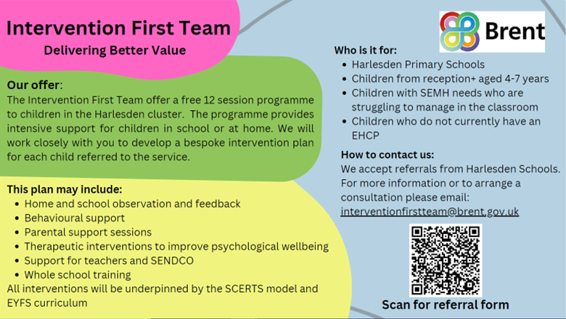

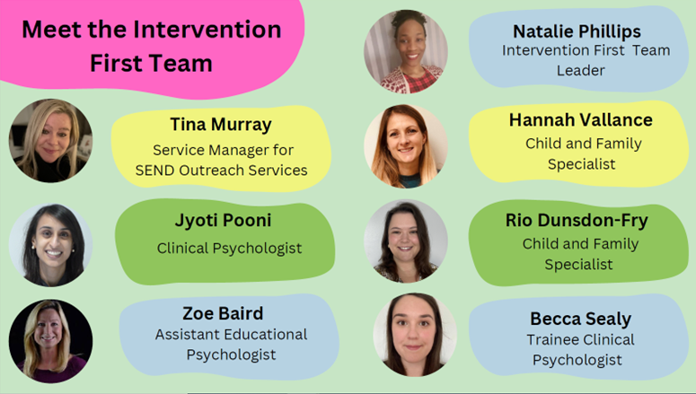

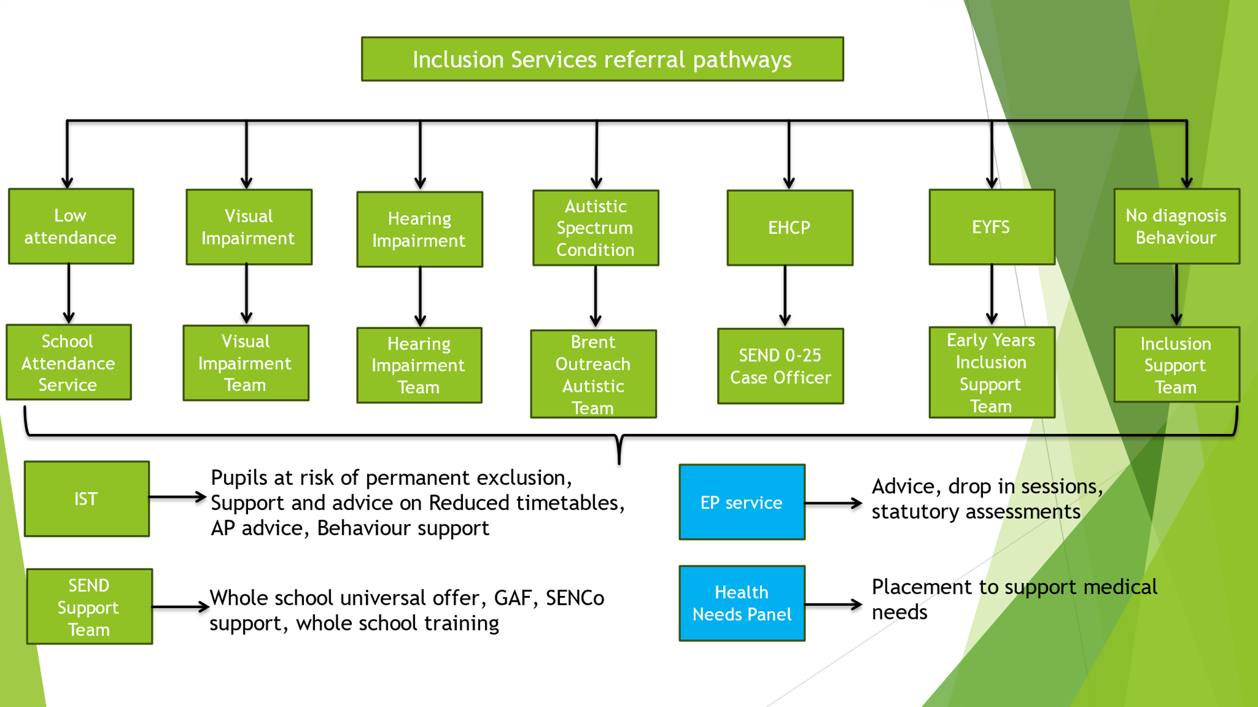

**Brent Deaf & Hearing Support Service**

